IP STATIC ROUTING

15.0.1

Why should I take this module?

Welcome to IP Static Routing!

There are so many different ways to dynamically route a packet that you might wonder why anybody would take the time to manually configure a static route. It is kind of like handwashing all of your clothes when you have a perfectly good washing machine. But you know that some clothing items cannot go in the washing machine. Some items benefit from being washed by hand. There is a similarity in networking. As it turns out, there are many situations where a manually configured a static route is your best option.

There are different kinds of static routes, and each is perfect for solving (or avoiding) a specific type of network problem. Many networks use both dynamic and static routing, so network administrators need to know how to configure, verify, and troubleshoot static routes. You are taking this course because you want to become a network administrator, or you want to improve your existing network administrator skills. You will be glad you took this module, because you will use these skills frequently! And because this module is about configuring static routes, there are several Syntax Checker activities, followed by a Packet Tracer and a Lab where you can hone your skills!

15.0.2

What will I learn to do in this module?

**Module Title**: IP Static Routing

**Module Objective**: Configure IPv4 and IPv6 static routes.

| Table caption | |
| --- | --- |
| **Topic Title** | **Topic Objective** |
| **Static Routes** | Describe the command syntax for static routes. |
| **Configure IP Static Routes** | Configure IPv4 and IPv6 static routes. |
| **Configure IP Default Static Routes** | Configure IPv4 and IPv6 default static routes. |
| **Configure Floating Static Routes** | Configure a floating static route to provide a backup connection. |
| **Configure Static Host Routes** | Configure IPv4 and IPv6 static host routes that direct traffic to a specific host. |

15.1.1

## Types of Static Routes

Static routes are commonly implemented on a network. This is true even when there is a dynamic routing protocol configured. For instance, an organization could configure a default static route to the service provider and advertise this route to other corporate routers using the dynamic routing protocol.

Static routes can be configured for IPv4 and IPv6. Both protocols support the following types of static routes:

* Standard static route
* Default static route
* Floating static route
* Summary static route

Static routes are configured using the **ip route** and **ipv6 route** global configuration commands.

15.1.2

## Next-Hop Options

When configuring a static route, the next hop can be identified by an IP address, exit interface, or both. How the destination is specified creates one of the three following types of static route:

* **Next-hop route** - Only the next-hop IP address is specified
* **Directly connected static route** - Only the router exit interface is specified
* **Fully specified static route** - The next-hop IP address and exit interface are specified

15.1.3

## IPv4 Static Route Command

* IPv4 static routes are configured using the following global configuration command:



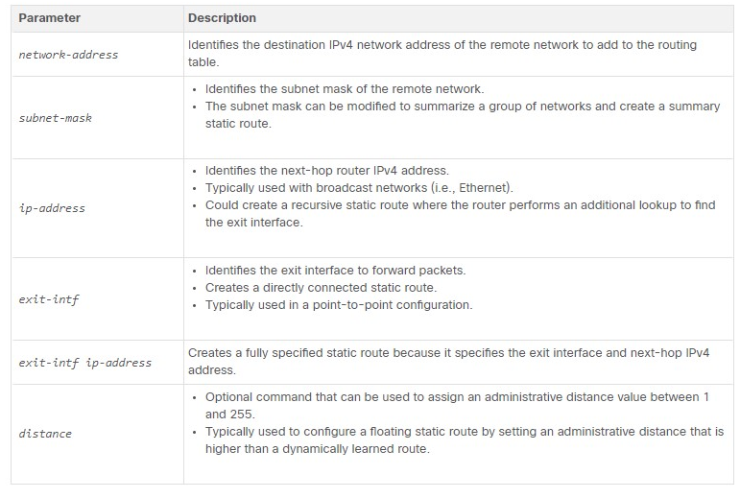

15.1.4

IPv6 Static Route Command

IPv6 static routes are configured using the following global configuration command:



The table shows the various **ipv6 route** command parameters and their descriptions

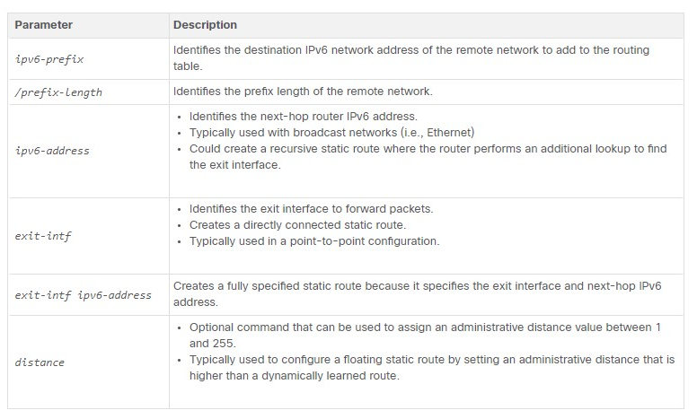

**Note**: The **ipv6 unicast-routing** global configuration command must be configured to enable the router to forward IPv6 packets.

15.1.5

Dual-Stack Topology

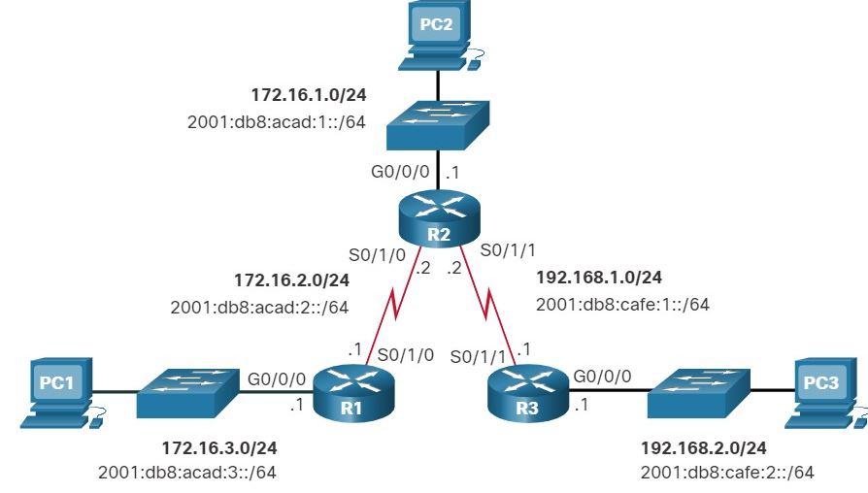

15.1.6

IPv4 Starting Routing Tables

**R1 IPv4 Routing Table**

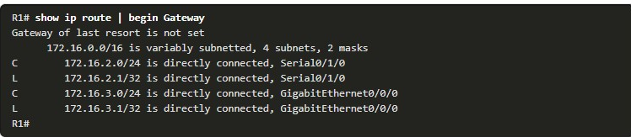

**R2 IPv4 Routing Table**

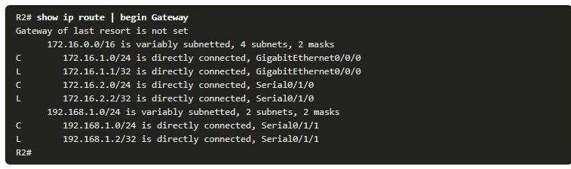

**R3 IPv4 Routing Table**

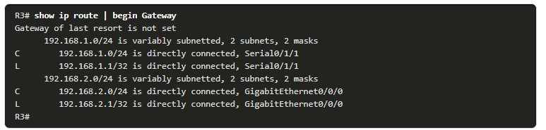

**R1 Can Ping R2**

None of the routers have knowledge of any networks beyond the directly connected interfaces. This means each router can only reach directly connected networks, as demonstrated in the following ping tests.

A **ping** from R1 to the serial 0/1/0 interface of R2 should be successful because it is a directly-connected network.

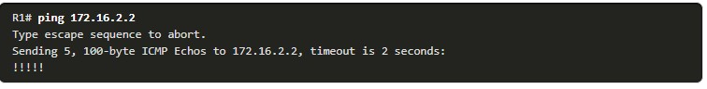

**R1 Cannot Ping R3 LAN**

However, a **ping** from R1 to the R3 LAN should fail because R1 does not have an entry in its routing table for the R3 LAN network.

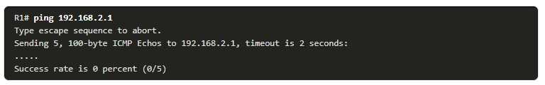

15.1.7

IPv6 Starting Routing Tables

**R1 IPv6 Routing Table**

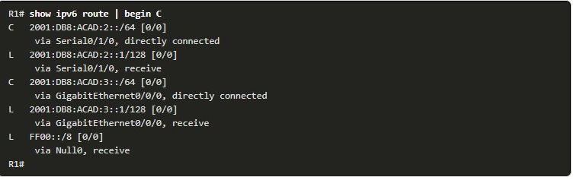

**R2 IPv6 Routing Table**

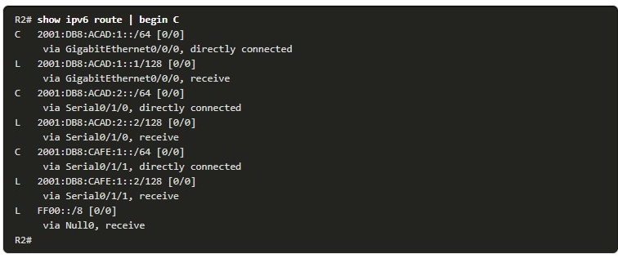

**R3 IPv6 Routing Table**

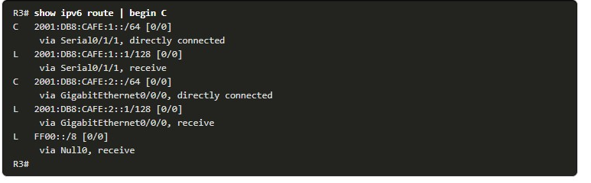

**R1 Can Ping R2**

None of the routers have knowledge of any networks beyond the directly connected interfaces.

A **ping** from R1 to the serial 0/1/0 interface on R2 should be successful.

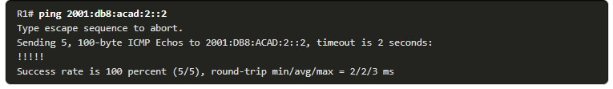

**R1 Cannot Ping R3 LAN**

However, a **ping** to the R3 LAN is unsuccessful. This is because R1 does not have an entry in its routing table for that network

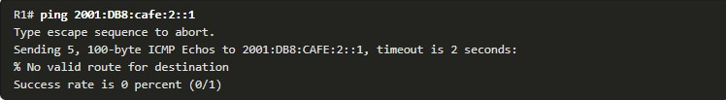

Yo

1. Which two methods can be used to identify the next hop in a static route? (Choose two.)



destination interface



next hop IP address



destination network address



exit interface



source IP address

**ANS: When configuring a static route, the next hop can be identified by an IP address, exit interface.**

1. Which IPv4 static route statement is true?



The destination network is identified using the network address and wildcard mask.



The **distance** keyword is used to create a fully specified static route.



The source network is identified using the network address and wildcard mask.



Using the exit interface only is common in a point-to-point configuration.

**ANS: Using the exit interface only is common in a point-to-point configuration**.

1. How is the destination network in an IPv6 static route identified?



using an IPv6 prefix and prefix length



using an IPv6 prefix and subnet mask



using an IPv6 prefix and wildcard mask



using an IPv6 prefix only

**ANS: The destination network in an IPv6 static route identified using an IPv6 prefix and prefix length**

CONFIGURE IP STATIC ROUTES

15.2.1

IPv4 Next-Hop Static Route

The commands to configure standard static routes varies slightly between IPv4 and IPv6. This topic shows you how to configure standard next-hop, directly connected, and full specified static routes for both IPv4 and Ipv6.

In a next-hop static route, only the next-hop IP address is specified. The exit interface is derived from the next hop. For example, three next-hop IPv4 static routes are configured on R1 using the IP address of the next hop, R2.

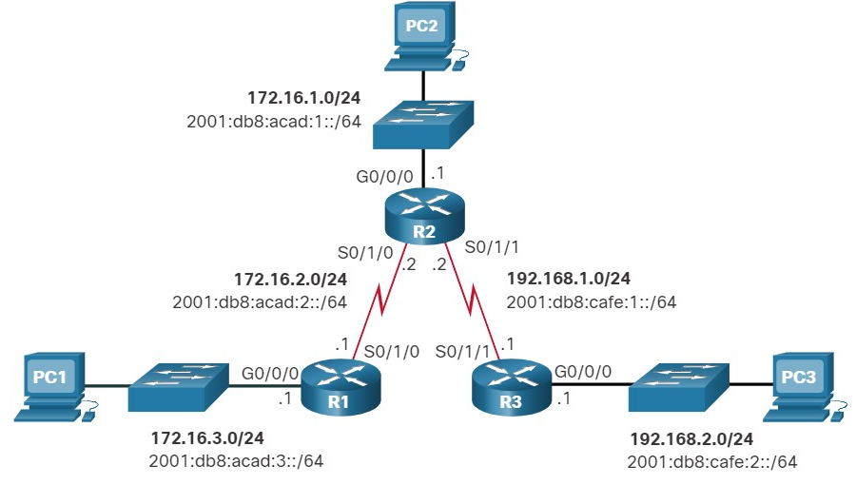

The commands to configure R1 with the IPv4 static routes to the three remote networks are as follows:



The routing table for R1 now has routes to the three remote IPv4 networks.

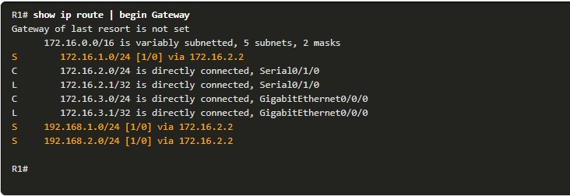

15.2.2

IPv6 Next-Hop Static Route

The commands to configure R1 with the IPv6 static routes to the three remote networks are as follows:

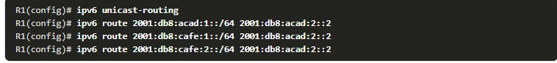

The routing table for R1 now has routes to the three remote IPv6 networks.

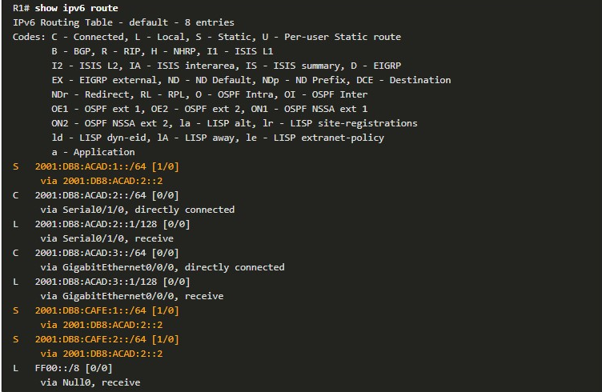

## IPv4 Directly Connected Static Route

When configuring a static route, another option is to use the exit interface to specify the next-hop address. The figure shows the topology again.

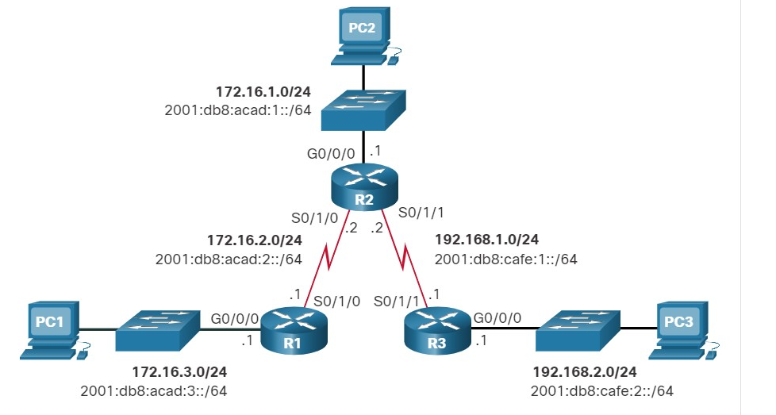

Three directly connected IPv4 static routes are configured on R1 using the exit interface.

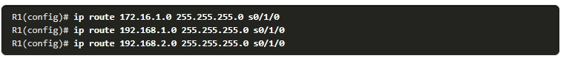

The IPv4 routing table for R1 shows that when a packet is destined for the 192.168.2.0/24 network, R1 looks for a match in the routing table, and finds that it can forward the packet out of its Serial 0/1/0 interface.

**Note**: Using a next-hop address is generally recommended. Directly connected static routes should only be used with point-to-point serial interfaces, as in this example

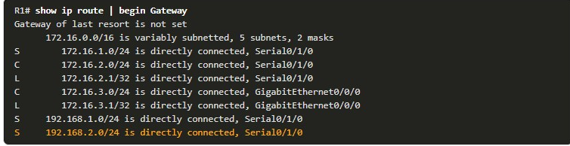

15.2.4

IPv6 Directly Connected Static Route

In the example, three directly connected IPv6 static routes are configured on R1 using the exit interface.

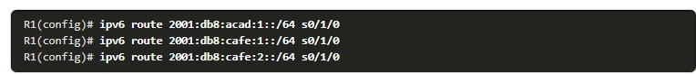

The IPv6 routing table for R1 in the example output shows that when a packet is destined for the 2001:db8:cafe:2::/64 network, R1 looks for a match in the routing table and finds that it can forward the packet out of its Serial 0/1/0 interface.

**Note**: Using a next-hop address is generally recommended. Directly connected static routes should only be used with point-to-point serial interfaces, as in this example.

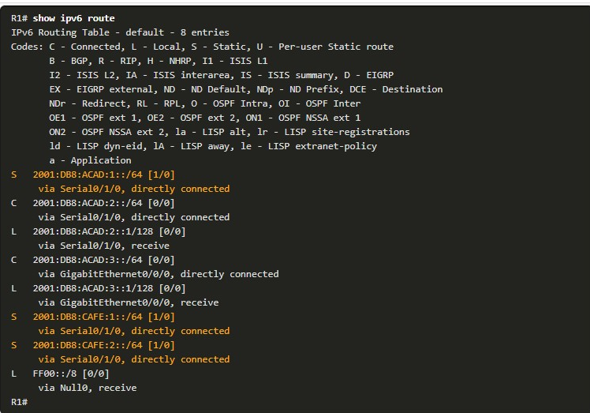

15.2.5

IPv4 Fully Specified Static Route

In a fully specified static route, both the exit interface and the next-hop IP address are specified. This form of static route is used when the exit interface is a multi-access interface and it is necessary to explicitly identify the next hop. The next hop must be directly connected to the specified exit interface. Using an exit interface is optional, however it is necessary to use a next-hop address.

Suppose that the network link between R1 and R2 is an Ethernet link and that the GigabitEthernet 0/0/1 interface of R1 is connected to that network, as shown in the figure.

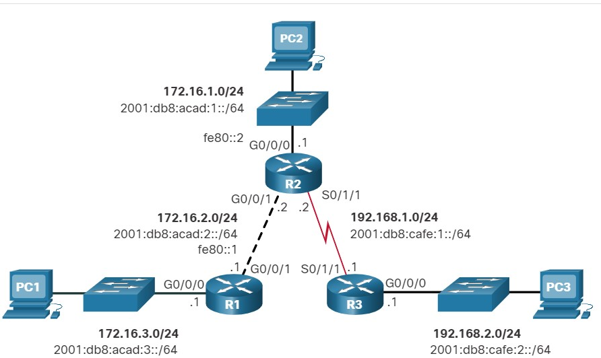

The difference between an Ethernet multi-access network and a point-to-point serial network is that a point-to-point serial network has only one other device on that network, the router at the other end of the link. With Ethernet networks, there may be many different devices sharing the same multi-access network, including hosts and even multiple routers.

It is recommended that when the exit interface is an Ethernet network, that the static route includes a next-hop address. You can also use a fully specified static route that includes both the exit interface and the next-hop address.



When forwarding packets to R2, the exit interface is GigabitEthernet 0/0/1 and the next-hop IPv4 address is 172.16.2.2 as shown in the **show ip route** output from R1.

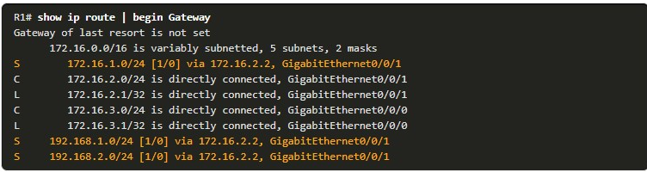

15.2.6

IPv6 Fully Specified Static Route

In a fully specified IPv6 static route, both the exit interface and the next-hop IPv6 address are specified. There is a situation in IPv6 when a fully specified static route must be used. If the IPv6 static route uses an IPv6 link-local address as the next-hop address, use a fully specified static route. The figure shows an example of a fully specified IPv6 static route using an IPv6 link-local address as the next-hop address.

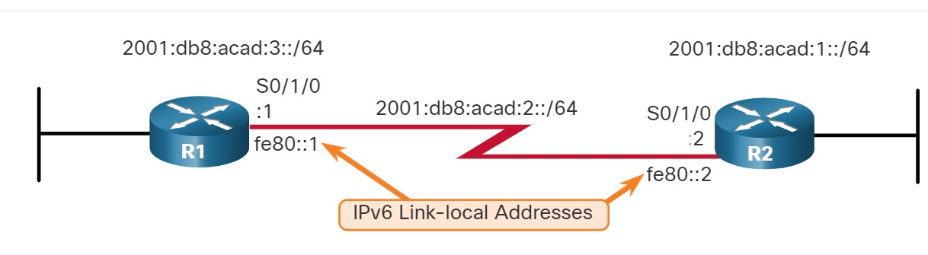

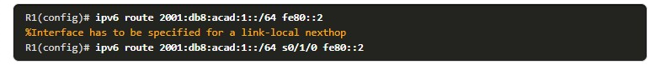

In the example, a fully specified static route is configured using the link-local address of R2 as the next-hop address. Notice that IOS requires that an exit interface be specified.

The reason a fully specified static route must be used is because IPv6 link-local addresses are not contained in the IPv6 routing table. Link-local addresses are only unique on a given link or network. The next-hop link-local address may be a valid address on multiple networks connected to the router. Therefore, it is necessary that the exit interface be included.

The following example shows the IPv6 routing table entry for this route. Notice that both the next-hop link-local address and the exit interface are included.

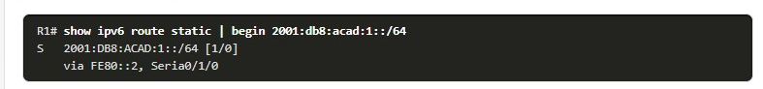

15.2.7

## Verify a Static Route

Along with **show ip route**, **show ipv6 route**, **ping** and **traceroute**, other useful commands to verify static routes include the following:

* **show ip route static**
* **show ip route** network
* **show running-config | section ip route**

Replace **ip** with **ipv6** for the IPv6 versions of the command.

Reference the figure when reviewing the command examples.

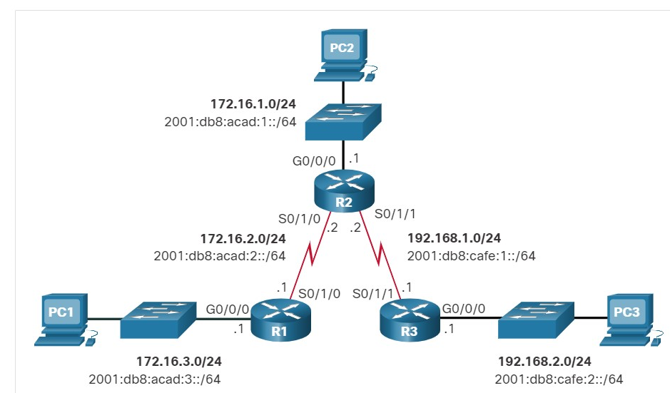

1. **Display only ipv4 static routes**

This output shows only the IPv4 static routes in the routing table. Also note where the filter begins the output, excluding all the codes.

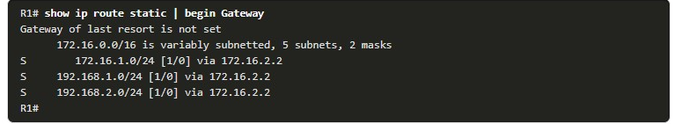

2. **Display a Specific IPv4 Network**

This command will show output for only the specified network in the routing table.

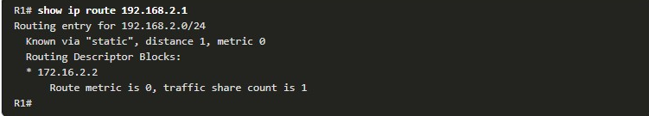

**3.Display the IPv4 Static Route Configuration**

This command filters the running configuration for only IPv4 static routes.

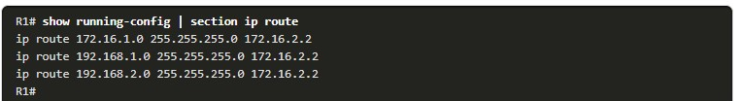

1. **Display Only IPv6 Static Routes**

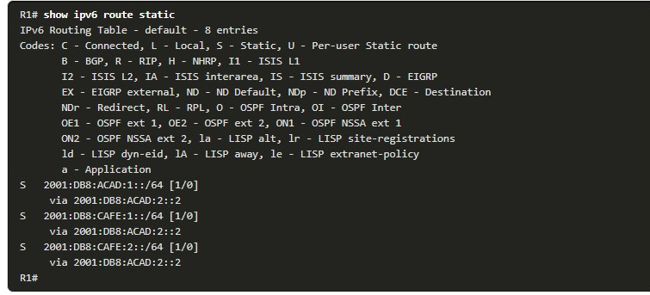

1. **Display a Specific IPv6 Network**

This command will show output for only the specified network in the routing table.

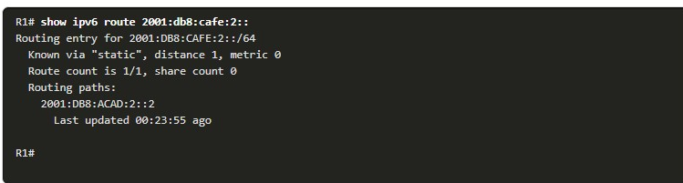

1. **Display the IPv6 Static Route Configuration**

This command filters the running configuration for only IPv6 static routes.

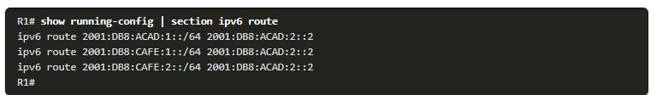

CONFIGURE IP DEFAULT STATIC ROUTES

15.3.1

Default Static Route

This topic shows you how to configure a default route for IPv4 and IPv6. It also explains the situations in which a default route is a good choice. A default route is a static route that matches all packets. Instead of routers storing routes for all of the networks in the internet, they can store a single default route to represent any network that is not in the routing table.

Routers commonly use default routes that are either configured locally or learned from another router, using a dynamic routing protocol. A default route does not require any far-left bits to match between the default route and the destination IP address. A default route is used when no other routes in the routing table match the destination IP address of the packet. In other words, if a more specific match does not exist, then the default route is used as the Gateway of Last Resort.

Default static routes are commonly used when connecting an edge router to a service provider network, or a stub router (a router with only one upstream neighbor router).

The figure shows a typical default static route scenario.

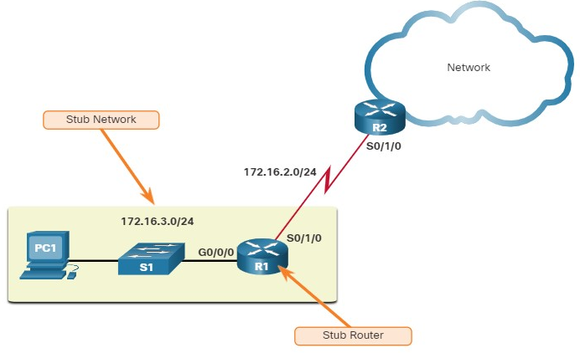

R1 only needs to know about directly connected networks. For all other networks it can use a default static route pointing to R2.

**IPv4 Default Static Route**

The command syntax for an IPv4 default static route is similar to any other IPv4 static route, except that the network address is **0.0.0.0** and the subnet mask is **0.0.0.0**. The 0.0.0.0 0.0.0.0 in the route will match any network address.

**Note**: An IPv4 default static route is commonly referred to as a quad-zero route.

The basic command syntax for an IPv4 default static route is as follows:



**IPv6 Default Static Route**

The command syntax for an IPv6 default static route is similar to any other IPv6 static route, except that the ipv6-prefix/prefix-length is **::/0**, which matches all routes.

The basic command syntax for an IPv6 default static route is as follows:



15.3.2

Configure a Default Static Route

In the figure, R1 could be configured with three static routes, one to reach each of the remote networks in the example topology. However, R1 is a stub router because it is only connected to R2. Therefore, it would be more efficient to configure a single default static route.

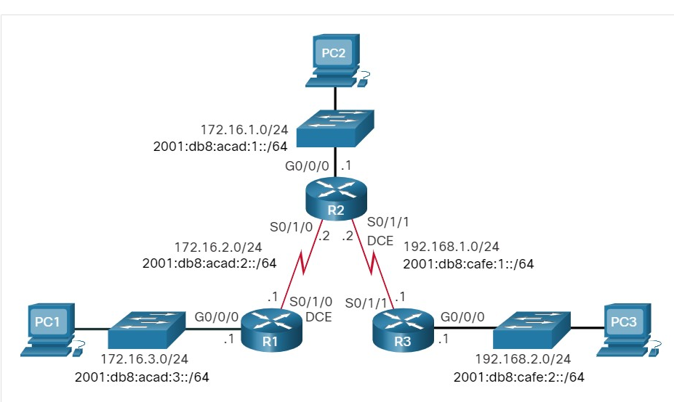

The example shows an IPv4 default static route configured on R1. With the configuration shown in the example, any packets not matching more specific route entries are forwarded to R2 at 172.16.2.2.

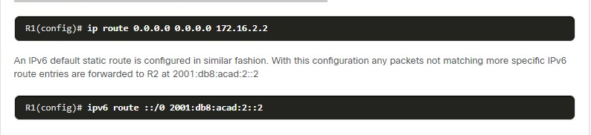

15.3.3

Verify a Default Static Route

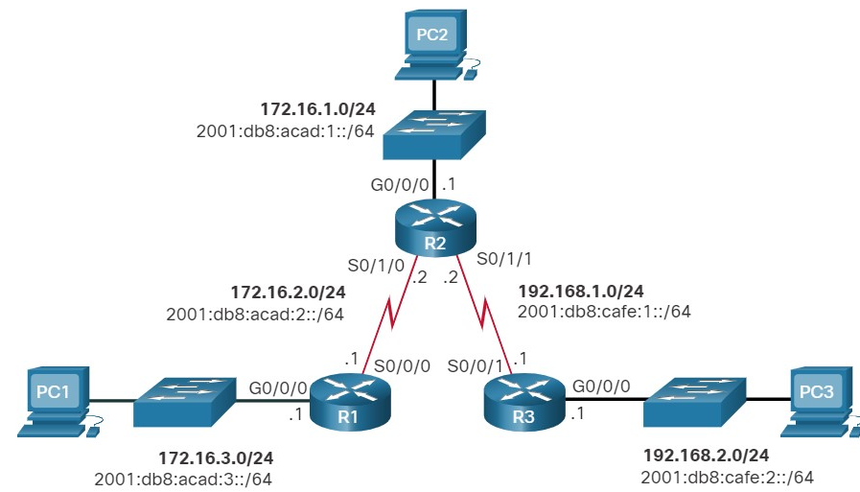

**Verify IPv4 Default Static Route**

The **show ip route static** command output from R1 displays the contents of the static routes in the routing table. Note the asterisk (*) next to the route with code ‘S’. As displayed in the codes table in the **show ip route** output, the asterisk indicates that this static route is a candidate default route, which is why it is selected as the Gateway of Last Resort.

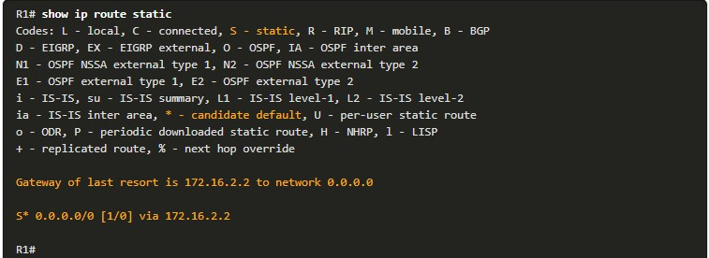

**Verify IPv6 Default Static Route**

This example shows the **show ipv6 route static** command output to display the contents of the routing table.

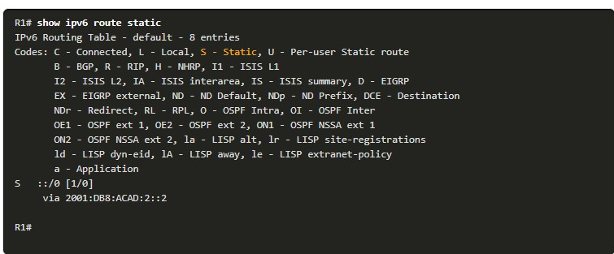

Notice that the static default route configuration uses the /0 mask for IPv4 default routes and the ::/0 prefix for IPv6 default routes. Remember that the IPv4 subnet mask and IPv6 prefix-length in a routing table determines how many bits must match between the destination IP address of the packet and the route in the routing table. A /0 mask or ::/0 prefix indicates that none of the bits are required to match. As long as a more specific match does not exist, the default static route matches all packets.

**CONFIGURE FLOATING STATIC ROUTES**

As with the other topics in this module, you will learn how to configure IPv4 and IPv6 floating static routes and when to use them.

Another type of static route is a floating static route. Floating static routes are static routes that are used to provide a backup path to a primary static or dynamic route, in the event of a link failure. The floating static route is only used when the primary route is not available.

To accomplish this, the floating static route is configured with a higher administrative distance than the primary route. The administrative distance represents the trustworthiness of a route. If multiple paths to the destination exist, the router will choose the path with the lowest administrative distance.

For example, assume that an administrator wants to create a floating static route as a backup to an EIGRP-learned route. The floating static route must be configured with a higher administrative distance than EIGRP. EIGRP has an administrative distance of 90. If the floating static route is configured with an administrative distance of 95, the dynamic route learned through EIGRP is preferred to the floating static route. If the EIGRP-learned route is lost, the floating static route is used in its place.

In the figure, the branch router typically forwards all traffic to the HQ router over the private WAN link. In this example, the routers exchange route information using EIGRP. A floating static route, with an administrative distance of 91 or higher, could be configured to serve as a backup route. If the private WAN link fails and the EIGRP route disappears from the routing table, the router selects the floating static route as the best path to reach the HQ LAN.

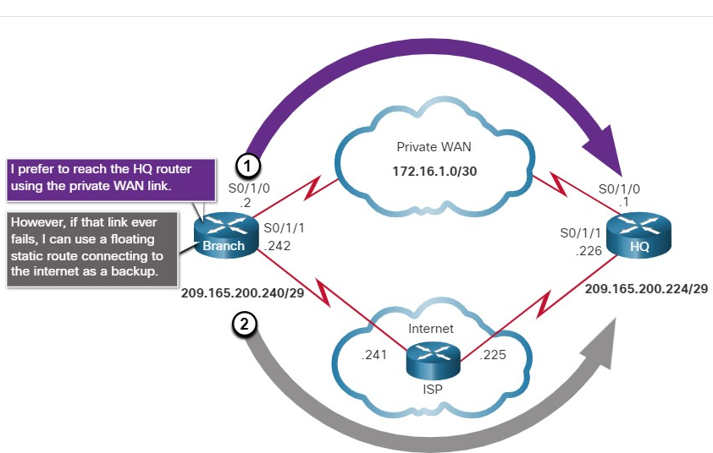

sA route learned through dynamic routing is preferred.

1. If a dynamic route is lost, the floating static route will be used.

By default, static routes have an administrative distance of 1, making them preferable to routes learned from dynamic routing protocols. For example, the administrative distances of some common interior gateway dynamic routing protocols are:

* EIGRP = 90
* OSPF = 110
* IS-IS = 115

The administrative distance of a static route can be increased to make the route less desirable than that of another static route or a route learned through a dynamic routing protocol. In this way, the static route “floats” and is not used when the route with the better administrative distance is active. However, if the preferred route is lost, the floating static route can take over, and traffic can be sent through this alternate route.

15.4.2

Configure IPv4 and IPv6 Floating Static Routes

IP floating static routes are configured by using the **distance** argument to specify an administrative distance. If no administrative distance is configured, the default value (1) is used.

Refer to the topology in the figure and the **ip route** and **ipv6 route** commands issued on R1. In this scenario, the preferred default route from R1 is to R2. The connection to R3 should be used for backup only.

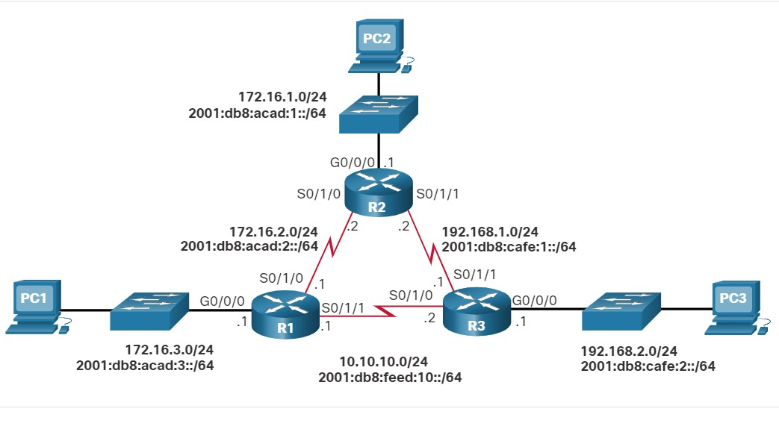

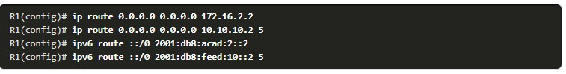

R1 is configured with IPv4 and IPv6 default static routes pointing to R2. Because no administrative distance is configured, the default value (1) is used for these static routes. R1 is also configured with IPv4 and IPv6 floating static default routes pointing to R3 with an administrative distance of 5. This value is greater than the default value of 1 and therefore; this route floats and is not present in the routing table unless the preferred route fails.

The **show ip route** and **show ipv6 route** output verifies that the default routes to R2 are installed in the routing table. Note that the IPv4 floating static route to R3 is not present in the routing table.

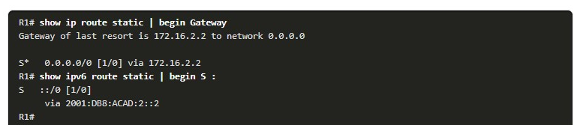

Use the **show run** command to verify that floating static routes are in the configuration. For example, the following command output verifies that both IPv6 static default routes are in the running configuration.

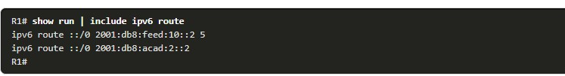

15.4.3

Test the Floating Static Route

In the figure, what would happen if R2 failed?

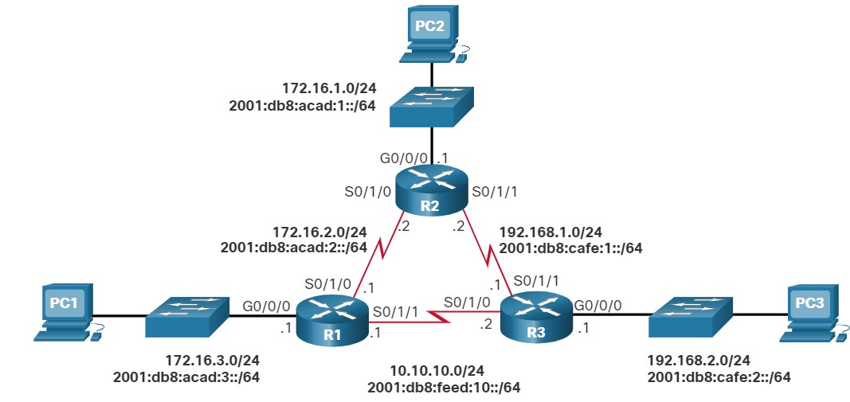

To simulate this failure, both serial interfaces of R2 are shut down, as shown in the configuration.

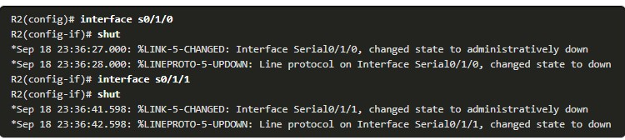

Notice that R1 automatically generates messages indicating that the serial interface to R2 is down.

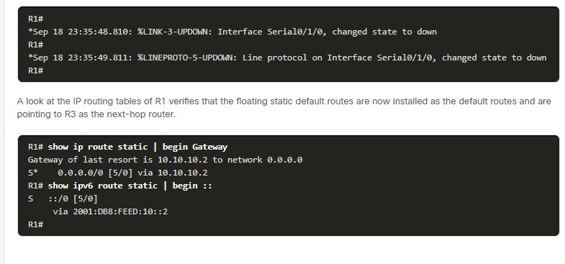

**CONFIGURE STATIC HOSTS ROUTES**

15.5.1

## Host Routes

This topic shows you how to configure an IPv4 and IPv6 static host route and when to use them.

A host route is an IPv4 address with a 32-bit mask, or an IPv6 address with a 128-bit mask. The following shows the three ways a host route can be added to the routing table:

* Automatically installed when an IP address is configured on the router (as shown in the figures)
* Configured as a static host route
* Host route automatically obtained through other methods (discussed in later courses)

15.5.2

## Automatically Installed Host Routes

Cisco IOS automatically installs a host route, also known as a local host route, when an interface address is configured on the router. A host route allows for a more efficient process for packets that are directed to the router itself, rather than for packet forwarding. This is in addition to the connected route, designated with a **C** in the routing table for the network address of the interface.

When an active interface on a router is configured with an IP address, a local host route is automatically added to the routing table. The local routes are marked with **L** in the output of the routing table.

For example, refer to the topology in the figure.

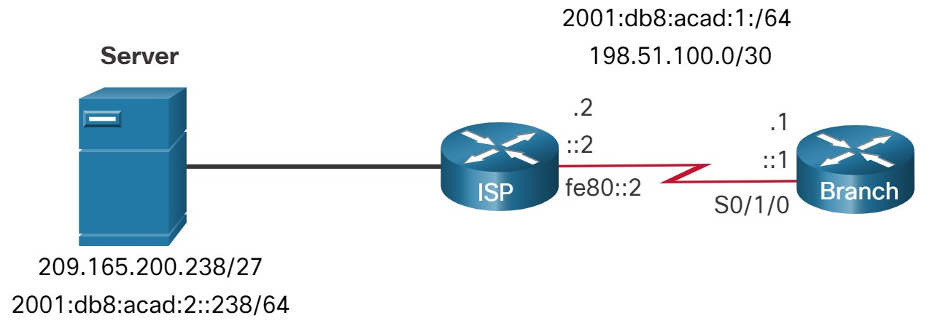

The IP addresses assigned to the Branch Serial0/1/0 interface are 198.51.100.1/30 and 2001:db8:acad:1::1/64. The local routes for the interface are installed by the IOS in the IPv4 and IPv6 routing tables, as shown in the example.

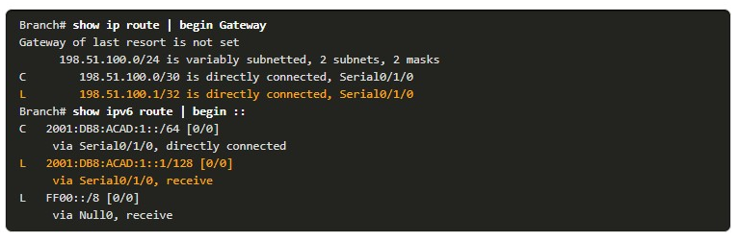

15.5.3

Static Host Routes

A host route can be a manually configured static route to direct traffic to a specific destination device, such as the server shown in the figure. The static route uses a destination IP address and a 255.255.255.255 (/32) mask for IPv4 host routes, and a /128 prefix length for IPv6 host routes.

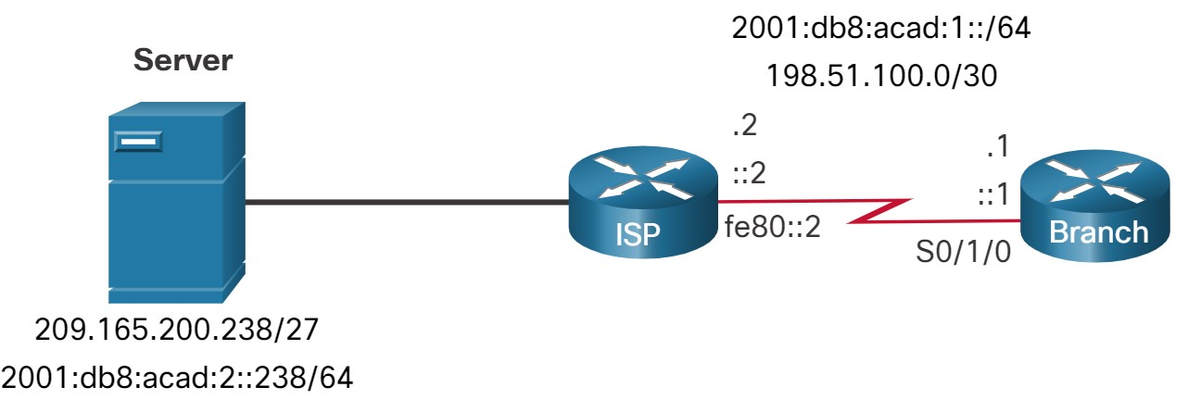

15.5.4

Configure Static Host Routes

The example shows the IPv4 and IPv6 static host route configuration on the Branch router to access the server.

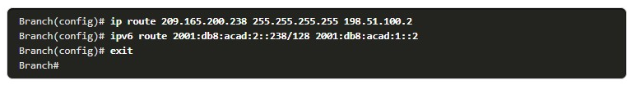

15.5.5

Verify Static Host Routes

A review of both the IPv4 and IPv6 route tables verifies that the routes are active.

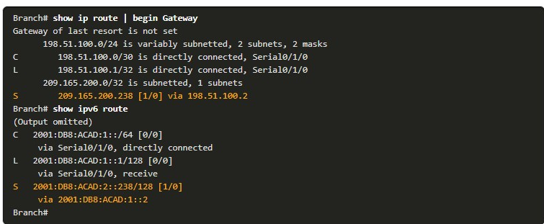

15.5.6

Configure IPv6 Static Host Route with Link-Local Next-Hop

For IPv6 static routes, the next-hop address can be the link-local address of the adjacent router. However, you must specify an interface type and an interface number when using a link-local address as the next hop, as shown in the example. First, the original IPv6 static host route is removed, then a fully specified route configured with the IPv6 address of the server and the IPv6 link-local address of the ISP router.

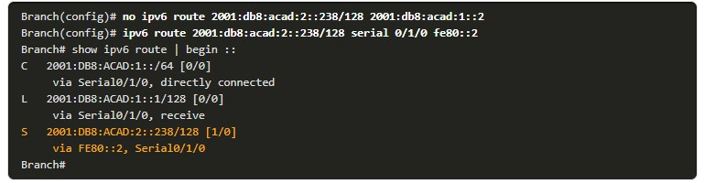

15.6.1

Packet Tracer - Configure IPv4 and IPv6 Static and Default Routes (pending)

In this Packet Tracer summary activity, you will configure static, default, and floating static routes for both the IPv4 and IPv6 protocols.

15.6.2

## Lab - Configure IPv4 and IPv6 Static and Default Routes (pending)

In this lab, you will complete the following objectives:

* Part 1: Build the Network and Configure Basic Device Settings
* Part 2: Configure and Verify IP and IPv6 Addressing on R1 and R2
* Part 3: Configure and Verify Static and Default Routing for IPv4 on R1 and R2
* Part 4: Configure and Verify Static and Default Routing for IPv6 on R1 and R2

15.6.3

What did I learn in this module?

**Static Routes**

Static routes can be configured for IPv4 and IPv6. Both protocols support the following types of static routes: standard static route, default static route, floating static route, and summary static route. Static routes are configured using the ip route and ipv6 route global configuration commands. When configuring a static route, the next hop can be identified by an IP address, exit interface, or both. How the destination is specified creates one of the three following types of static route: next-hop, directly connected, and fully specified. IPv4 static routes are configured using the following global configuration command: **ip route** *network-address subnet-mask* { *ip-address* | *exit-intf* [*ip=address*] } [**distance**]. IPv6 static routes are configured using the following global configuration command: **ipv6 route** *ipv6-prefix/prefix-length* { *ipv6-address* | *exit-intf* [*ipv6-address*]} [**distance**]. The command to start an IPv4 routing table is **show ip route** | **begin Gateway**. The command to start an IPv6 routing table is **show ipv6 route** | **begin C.**

**Configure IP Static Routes**

In a next-hop static route, only the next-hop IP address is specified. The exit interface is derived from the next hop. When configuring a static route, another option is to use the exit interface to specify the next-hop address. Directly connected static routes should only be used with point-to-point serial interfaces. In a fully specified static route, both the exit interface and the next-hop IP address are specified. This form of static route is used when the exit interface is a multi-access interface and it is necessary to explicitly identify the next hop. The next hop must be directly connected to the specified exit interface. In a fully specified IPv6 static route, both the exit interface and the next-hop IPv6 address are specified. Along with **show ip route**, **show ipv6 route**, **ping** and **traceroute**, other useful commands to verify static routes include: **show ip route static**, **show ip route** *network*, and **show running-config | section ip route**. Replace ip with ipv6 for the IPv6 versions of the command.

**Configure IP Default Static Routes**

A default route is a static route that matches all packets. A default route does not require any far-left bits to match between the default route and the destination IP address. Default static routes are commonly used when connecting an edge router to a service provider network, and a stub router. The command syntax for an IPv4 default static route is similar to any other IPv4 static route, except that the network address is 0.0.0.0 and the subnet mask is 0.0.0.0. The 0.0.0.0 0.0.0.0 in the route will match any network address. The command syntax for an IPv6 default static route is similar to any other IPv6 static route, except that the ipv6-prefix/prefix-length is ::/0, which matches all routes. To verify an IPv4 default static route, use the **show ip route static** command. For IPV6 use the **show ipv6 route static** command.

**Configure Floating Static Routes**

Floating static routes are static routes that are used to provide a backup path to a primary static or dynamic route in the event of a link failure. The floating static route is configured with a higher administrative distance than the primary route. By default, static routes have an administrative distance of 1, making them preferable to routes learned from dynamic routing protocols. The administrative distances of some common interior gateway dynamic routing protocols are EIGRP = 90, OSPF = 110, and IS-IS = 115. IP floating static routes are configured by using the **distance** argument to specify an administrative distance. If no administrative distance is configured, the default value (1) is used. The **show ip route** and **show ipv6 route** output verifies that the default routes to a router are installed in the routing table.

**Configure Static Host Routes**

A host route is an IPv4 address with a 32-bit mask or an IPv6 address with a 128-bit mask. There are three ways a host route can be added to the routing table: automatically installed when an IP address is configured on the router, configured as a static host route, or automatically obtained through other methods not covered in this module. Cisco IOS automatically installs a host route, also known as a local host route, when an interface address is configured on the router. A host route can be a manually configured static route to direct traffic to a specific destination device. For IPv6 static routes, the next-hop address can be the link-local address of the adjacent router; however, you must specify an interface type and an interface number when using a link-local address as the next hop. To do this, the original IPv6 static host route is removed, then a fully specified route is configured with the IPv6 address of the server and the IPv6 link-local address of the ISP router.

1. A network administrator configures a router by the command **ip route 0.0.0.0 0.0.0.0 209.165.200.226**. What is the purpose of this command?

Topic 15.3.0 - The command **ip route 0.0.0.0 0.0.0.0** <*next hop*> adds a default route to the routing table of a router. When the router receives a packet and does not have a specific route toward the destination, it forwards the packet to the next hop indicated in the default route. A route created with the **ip route** command is a static route, not a dynamic route.



to add a dynamic route for the destination network 0.0.0.0 to the routing table



to forward packets destined for the network 0.0.0.0 to the device with IP address 209.165.200.226



to forward all packets to the device with IP address 209.165.200.226



to provide a route to forward packets for which there is no route in the routing table

1. Which type of static route that is configured on a router uses only the exit interface?

Topic 15.2.0 - When only the exit interface is used, the route is a directly connected static route. When the next-hop IP address is used, the route is a recursive static route. When both are used, it is a fully specified static route.



default static route



recursive static route



fully specified static route



directly connected static route

1. A network administrator uses the command **ip route 172.18.0.0 255.255.0.0 S0/0/1** to configure a floating static route on a router. That route will function as a backup route to reach the EIGRP learned network 172.18.0.0/16. After this configuration, the EIGRP route is removed from the routing table even though EIGRP is still functioning properly. Why is the static route not functioning as intended?

Topic 15.4.0 - A floating static route requires an administrative distance greater than that of the dynamic routing protocol in order to be used as a backup route. In this problem an administrative distance greater than 90 would have to be added to the static route:  ip route 172.18.0.0 255.255.0.0 S0/0/1 100.



The administrative distance value is not high enough on the static route.



The next hop neighbor IP address is not configured.



The destination network is incorrectly configured.



The network mask is incorrectly configured.

1. What type of static route is created when the next-hop IP address and exit interface are specified?

Topic 15.2.0 - A fully specified static route has the next-hop IP address and exit interface specified. A recursive static route has only the next-hop IP address specified. A directly attached static route has only the router exit interface specified. A floating static route has a higher metric than the dynamic routes and serves as a backup route.



directly connected static route



recursive static route



floating static route



fully specified static route

1. What is the correct syntax of a floating static route?

Topic 15.4.0 - Floating static routes are used as backup routes, often to routes learned from dynamic routing protocols. To be a floating static route, the configured route must have a higher administrative distance than the primary route. For example, if the primary route is learned through OSPF, then a floating static route that serves as a backup to the OSPF route must have an administrative distance greater than 110. The administrative distance on a floating static route is put at the end of the static route: **ip route  209.165.200.228 255.255.255.248 10.0.0.1 120**.



**ip route 0.0.0.0 0.0.0.0 serial 0/0/0**



**ip route 209.165.200.228 255.255.255.248 10.0.0.1 120**



**ip route 172.16.0.0 255.248.0.0 10.0.0.1**



**ip route 209.165.200.228 255.255.255.248 serial 0/0/0**

1. Which static route statement shows a recursive IPv6 static route?

Topic 15.1.0 - In a recursive static route, only the next-hop IPv6 address is specified. As a consequence, the router must perform a recursive route table lookup to find an exit interface associated with the network of the IPv6 address.



ipv6 route 2001:db8:cafe:1::/56 2001:db8:1000:10::1



ipv6 route 2001:db8:cafe:1::/56 S0/0/0 2001:db8:1000:10::1



ipv6 route 2001:db8:cafe:1::/56 S0/0/0



ipv6 route 0::/0 S0/0/0



ipv6 route 0::/0 S0/0/0 254

1. A network administrator is configuring a route to forward packets to a specific web server. What type of route should be configured by the administrator?

Topic 15.5.0 - A host route is a route installed in the routing table where the destination address has a subnet mask of /32 for IPv4 or /128 for IPv6, an address of a specific device. A host route can allow for a more efficient processing of packets that are directed to the device, rather than for packet forwarding, such as by a default route, an OSPF route, or an EIGRP route.



a default route



an OSPF route



an EIGRP route



a static route with an administrative distance higher than 1



a host route

1. Which command would create a valid IPv6 default route?

Topic 15.3.0 - The correct prefix and prefix length for a default route is ::/0, which matches any address. ::/128 matches only the specific address of all zeros. When creating a static route that uses a link-local address as the next hop, an exit interface must also be specified for the route to be valid.



**ipv6 route 2001:db8:acad:1::/64 ::1**



**ipv6 route ::/0 2001:db8:acad:2::a**



**ipv6 route ::/0 fe80::1**



**ipv6 route ::/128 2001:db8:acad:1::1**

1. What is a characteristic of a default static route? ​

Topic 15.3.0 - A default static route is a route that matches all packets. It identifies the gateway IP address to which the router sends all IP packets for which the router does not have a learned or static route. A default static route is simply a static route with 0.0.0.0/0 as the destination IPv4 address. Configuring a default static route creates a gateway of last resort.​



It identifies the gateway IP address to which the router sends all IP packets for which it does not have a learned or static route.



It uses a single network address to send multiple static routes to one destination address.



It backs up a route already discovered by a dynamic routing protocol.



It is configured with a higher administrative distance than is the original dynamic routing protocol.

1. What is the purpose of a floating static route?

Topic 15.4.0 - A floating static route is a backup route with an administrative distance that is higher than a dynamically learned route or another static route. The purpose of a floating static route is to use a particular path to a destination network that is not the best route, but is used only when the preferred route is down.



It allows connectivity to remote destinations that are not contained in the routing table.



It is commonly used when a dynamic routing protocol is not being used.



It allows an alternate connection to be used when the preferred link fails.



It allows summarization of contiguous networks.

1. Which IPv6 static route would serve as a backup route to a dynamic route learned through OSPF?

Topic 15.4.0 - The command ipv6 route 2001:db8:acad:1::/32  2001:db8:acad:6::2 200, specifies a floating static route to the 2001:db8:acad:1::/32 network with an administrative distance of 200. Since OSPF has an administrative distance of 110, the static route would only be placed in the routing table if the OSPF learned route was removed.



Router1(config)# **ipv6 route 2001:db8:acad:1::/32  2001:db8:acad:6::100**



Router1(config)# **ipv6 route 2001:db8:acad:1::/32  2001:db8:acad:6::2 200**



Router1(config)# **ipv6 route 2001:db8:acad:1::/32  2001:db8:acad:6::2 100**



Router1(config)# **ipv6 route 2001:db8:acad:1::/32  gigabitethernet0/0 2001:db8:acad:6::100 100**

1. What command, or set of commands, would be used to determine if the following configuration on router HQ works as designed?

**ip route  0.0.0.0 0.0.0.0 serial 0/0/0 10  
ip route 0.0.0.0 0.0.0.0 serial 0/1/0**

Topic 15.4.0 - To test a floating static route, take down the main route/link in order to see whether the backup link appears in the routing table. The **show ip route** command simply shows the routing table. Only one of the static routes would be shown at any one time.



HQ# **show ip route**



HQ(config)# **interface serial 0/1/0**  
HQ(config-if)# **shutdown**  
HQ(config-if)# **end**  
HQ# **show ip route**



HQ# **ping 128.107.0.99**  
HQ# **ping 64.100.0.5**



HQ# **show ip interface brief**



HQ# **traceroute 128.107.0.99**

1. Which type of static route typically uses the *distance* parameter in the **ip route** global configuration command?

Topic 15.4.0 - Because a floating static route is not designed to be used as a primary route, its configuration requires a higher administrative distance than the usual default value of 1. When set higher than the administrative distance for the current routing protocol, the *distance* parameter allows the route to be used only when the primary route fails. All other forms of static routes have specific uses as primary routes.



standard static route



floating static route



summary static route



default static route

1. Why would a floating static route be configured with an administrative distance that is higher than the administrative distance of a dynamic routing protocol that is running on the same router?

Topic 15.4.0 - By default, dynamic routing protocols have a higher administrative distance than static routes. Configuring a static route with a higher administrative distance than that of the dynamic routing protocol will result in the dynamic route being used instead of the static route. However, should the dynamically learned route fail, then the static route will be used as a backup.



to be the priority route in the routing table



to act as a gateway of last resort



to be used as a backup route



to load-balance the traffic

1. What network address and subnet mask combination would be used to create a default static route that matches any IPv4 destination?

Topic 15.3.0 - For a route to be considered a default static route it must use a network ID and subnetmask combination that will match any destination IP address. The address and mask of 0.0.0.0 0.0.0.0 in a static route will create a route table entry that matches any destination.



0.0.0.0 255.255.255.255



255.255.255.255 255.255.255.255



0.0.0.0 0.0.0.0



255.255.255.255 0.0.0.0